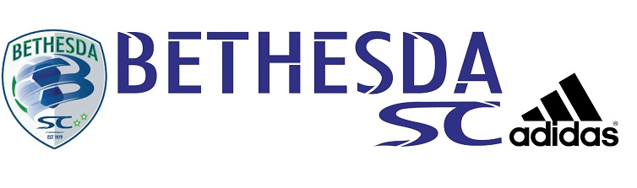Bethesda SC Summer
High School Soccer League

Girls JV Schedule

BEES
CLARKSBURG
COUGARS RED
ROCKETS WHITE
ROCKVILLE RAMS
WILDCATS WHITE

Thursday, June 13

5:00 p.m. Rockets White vs. Rockville Rams Wootton B
8:00 p.m. Clarksburg vs. Bees Wootton A
9:00 p.m. Cougars Red vs. Wildcats White Wootton B

Tuesday, June 18

5:00 p.m. Cougars Red vs. Rockets White Rich Mont B
6:00 p.m. Wildcats White vs. Bees Rich Mont B
8:00 p.m. Clarksburg vs. Rockville Rams Rich Mont B
Thursday, June 20

7:00 p.m. Wildcats White vs. Rockets White Rich Mont A
7:00 p.m. Clarksburg vs. Cougars Red Rich Mont B
8:00 p.m. Bees vs. Rockville Rams Wootton B

Tuesday, June 25

5:00 p.m. Wildcats White vs. Clarksburg Rich Mont B
7:00 p.m. Rockville Rams vs. Cougars Red Rich Mont A
9:00 p.m. Rockets White vs. Bees Rich Mont B

Thursday, June 27

5:00 p.m. Rockville Rams vs. Wildcats White Rich Mont A
5:00 p.m. Rockets White vs. Clarksburg Rich Mont B
8:00 p.m. Bees vs. Cougars Red Rich Mont A

Tuesday, July 2

6:00 p.m. Wildcats White vs. Cougars Red Rich Mont B
6:00 p.m. Bees vs. Clarksburg Wootton B
7:00 p.m. Rockville Rams vs. Rockets White Rich Mont B

Tuesday, July 9

5:00 p.m. Rockville Rams vs. Clarksburg Wootton A
6:00 p.m. Bees vs. Wildcats White Rich Mont A

Thursday, July 11

5:00 p.m. Rockville Rams vs. Bees Wootton A
7:00 p.m. Cougars Red vs. Clarksburg Rich Mont A
9:00 p.m. Rockets White vs. Wildcats White Wootton A

Tuesday, July 16

6:00 p.m. Clarksburg vs. Wildcats White Wootton B
9:00 p.m. Bees vs. Rockets White Rich Mont A
9:00 p.m. Cougars Red vs. Rockville Rams Rich Mont B

Thursday, July 18

6:00 p.m. Clarksburg vs. Rockets White Rich Mont B
8:00 p.m. Cougars Red vs. Bees Rich Mont B

Tuesday, July 23

5:00 p.m. Wildcats White vs. Rockville Rams Rich Mont A
6:00 p.m. Rockets White vs. Cougars Red Rich Mont A

