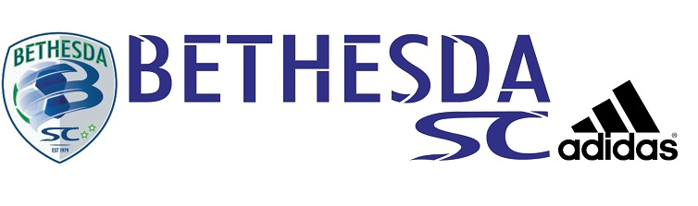Bethesda SC Summer
High School Soccer League

Boys JV Schedule

BLAIR DYNAMOS
CHURCHILL
QUINCE ORCHARD
RM ROCKETS
WJ BLACK
WJ YELLOW
WARRIORS

Thursday, June 13

5:00 p.m. Quince Orchard vs. RM Rockets Rich Mont B
6:00 p.m. Blair Dynamos vs. WJ Yellow Rich Mont A
7:00 p.m. Churchill vs. WJ Black Rich Mont A

Tuesday, June 18

6:00 p.m. WJ Black vs. Blair Dynamos Wootton B
7:00 p.m. WJ Yellow vs. Warriors Wootton B
8:00 p.m. RM Rockets vs. Churchill Wootton B
Thursday, June 20

5:00 p.m. Quince Orchard vs. WJ Yellow Rich Mont A
6:00 p.m. Churchill vs. Warriors Wootton B
6:00 p.m. RM Rockets vs. WJ Black Rich Mont A

Tuesday, June 25

5:00 p.m. WJ Yellow vs. Churchill Wootton A
6:00 p.m. WJ Black vs. Quince Orchard Wootton A
7:00 p.m. Warriors vs. Blair Dynamos Wootton A

Thursday, June 27

7:00 p.m. WJ Black vs. WJ Yellow Wootton B
9:00 p.m. Quince Orchard vs. Blair Dynamos Wootton A
9:00 p.m. RM Rockets vs. Warriors Wootton B

Tuesday, July 2

5:00 p.m. WJ Yellow vs. RM Rockets Rich Mont B
7:00 p.m. Blair Dynamos vs. Churchill Wootton B
8:00 p.m. Warriors vs. Quince Orchard Wootton B

Tuesday, July 9

6:00 p.m. Blair Dynamos vs. RM Rockets Rich Mont B
8:00 p.m. Churchill vs. Quince Orchard Wootton A
9:00 p.m. Warriors vs. WJ Black Wootton A

Thursday, July 11

6:00 p.m. WJ Black vs. Churchill Wootton B
7:00 p.m. WJ Yellow vs. Blair Dynamos Wootton B
9:00 p.m. RM Rockets vs. Quince Orchard Rich Mont B

Tuesday, July 16

5:00 p.m. Churchill vs. RM Rockets Wootton A
6:00 p.m. Warriors vs. WJ Yellow Wootton A
7:00 p.m. Blair Dynamos vs. WJ Black Wootton A
Thursday, July 18

5:00 p.m. Warriors vs. Churchill Rich Mont B
8:00 p.m. WJ Black vs. RM Rockets Wootton A
9:00 p.m. WJ Yellow vs. Quince Orchard Wootton A

Tuesday, July 23

5:00 p.m. Churchill vs. WJ Yellow Wootton A
6:00 p.m. Quince Orchard vs. WJ Black Wootton A
6:00 p.m. Blair Dynamos vs. Warriors Wootton B
8:00 p.m. Warriors vs. Quince Orchard Wootton A
9:00 p.m. RM Rockets vs. Blair Dynamos Wootton A

